H.T No
Regulations:
A22

Sreenidhi Institute of Science and Technology
(An Autonomous Institution)
Code No:9AC07 Date: 06-Feb-2025 (AN)

B.Tech II-Year II- Semester External Examination, Jan/Feb-2025 (Supplementary)
LINEAR CONTROL SYSTEMS (EEE)

Time: 3 Hours Max.Marks:60

Note: a) No additional answer sheets will be provided.
b) All sub-parts of a question must be answered at one place only, otherwise it will not be valued.
c) Missing data can be assumed suitably.
Bloom's Cognitive Levels of Learning (BCLL)

Remember | L1 | Apply | L3 | Evaluate | L5
Understand | L2 | Analyze | L4 | Create | L6

Part - A Max.Marks: 6x2=12

Answer all QUESTIONS, EACH QUESTION CARRIES 2 MARKS.

 |  | BCLL | CO(s) | Marks
1 | Give an example of a real-world closed-loop control system. | L1 | CO1 | [2M]
2 | Discuss how to reduce the steady state error of a control system. | L1 | CO2 | [2M]
3 | What are the limitations of Routh’s stability? | L1 | CO3 | [2M]
4 | Define gain margin. | L1 | CO4 | [2M]
5 | Draw the polar plot of G(s) = 1 /S(1+S) | L2 | CO5 | [2M]
6 | Mention any two advantages of state variable representation. | L1 | CO6 | [2M]

Part – B Max.Marks: 6x8=48
ANSWER ALL QUESTIONS. EACH QUESTION CARRIES 8 MARKS.

 |  | BCLL | CO(s) | Marks
7. | For the system represented by the block diagram shown in figure 1. Find C/R .  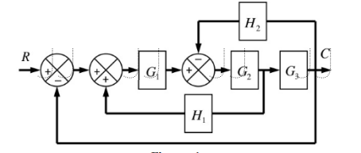 | L3 | CO1 | [8M]
 | OR
8 | Develop the differential equations governing the mechanical system as shown in below figure. Also find the transfer function X1(s) / F(s)  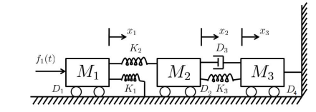 | L3 | CO1 | [8M]
9. | Define the following terms:  (i) Delay time (ii) Rise time (iii) Settling time (iv) Peak time  (v) Overshoot | L1 | CO2 | [8M]
 | OR
10 | The open-loop transfer function of a unity feedback control system is given by,  G(s) = 9 / s(s+3).  Find the natural frequency of response, damping ratio, damped frequency and time constant | L3 | CO2 | [8M]
11 | Examine the stability of the system represented by the characteristic equation using RH criterion, S⁴+ 2S³ +8S² + 4S + 3 = 0. | L3 | CO3 | [8M]
 | OR
12 | Drawthe root locus of the system whose open loop transfer function is, G(s) = K/s(s+10)(s+4) | L4 | CO3 | [8M]
13 | Define the following  i) Gain crossover frequency ii) Phase crossover frequency  iii) Gain Margin iv) Phase Margin | L1 | CO4 | [8M]
 | OR
14 | Construct the Bode plot for a system and find gain cross over frequency.  G(s) = K (s+3) / s(s+2)(s+4)(s+5) | L4 | CO4 | [8M]
15 | A unity feedback control system has an open loop transfer function given by G(s) H(s) =10 /s(s+3)(s+6).  Draw Nyquist plot and determine stability. | L4 | CO5 | [8M]
 | OR
16 | Derive the transfer function of lag-lead compensator. | L2 | CO5 | [8M]
17 | Define:  - State  - State variables  iii) iii) State space representation. | L1 | CO6 | [8M]
 | OR
18 | The state equation of a linear-time invariant system is given as,  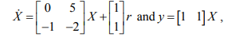  Find the transfer function. | L3 | CO6 | [8M]

-- 00 -- 00 –

